LEVERAGING O365 HIGH SPEED MIGRATION OFFERINGS

An Overview



**HCL Technologies**

**SharePoint Service Line – Modern Apps**

**Contents**

Background 2

Challenges using Traditional CSOM for Content Migration 2

Approach 2

Express Route 2

Disk Shipping 3

The Tool Perspective 5

Observations 5

Capabilities 6

Limitations 8

Supported and Unsupported features of HSM 9

References 9

**Figures**

Figure 1-High Speed Migration with Azure Express Route 3

Figure 2-Figure: High Speed Migration with Disk Shipping 4

Figure 3-Typical Life-cycle of Disk(s) 5

# **Background**

Migration of huge volumes of content from on-premises installations of SharePoint to multi-tenant O365 SharePoint Online used to be very time consuming using traditional CSOM APIs provisioned by Microsoft.

Migration of content volumes exceeding 500 GB which is heavily dependent on network factors like bandwidth, availability etc., will run into months.

Moreover, Microsoft imposes a number of restrictions on migrations using the traditional CSOM path.

## Challenges using Traditional CSOM for Content Migration

* Limitations on the number of Client Side Object Model (CSOM) calls, a particular user can initiate on Office 365 within a given timeframe – referred as user based throttling.
* Limitations on the number of CSOM calls that can be initiated against a particular Office 365 tenant or SharePoint Online farm within a given timeframe – referred as tenant based throttling.
* Bandwidth limitations when copying content from on-prem to O365.

*Note: Depending on usage, Microsoft used to fine-tune thresholds so that users can consume the maximum number of resources without degrading the reliability and performance of SharePoint Online. Hence no strictly defined thresholds/limitations are shared.*

In order to address the problem of large-scale migrations to O365 SharePoint online (that can potentially have adverse cost and timeline implications), Microsoft has launched a set of High Speed Migration APIs which can significantly boost migration speed by leveraging Microsoft Azure.

# **Approach**

Microsoft offers a couple of options for high speed migration to the O365 cloud from on-premises installations of SharePoint, namely the ‘**Express Route**’ and ‘**Disk/Drive Shipping**’.

## Express Route

The major steps of the Express Route include:

**Steps performed at customer end:**

* **Site structure on the target** environment including Sites/Subsites/Lists/Libraries etc. is **created before the actual migration** exercise commences
* The content to be migrated is de-constructed into smaller packages and corresponding manifest files (which carry information like content attributes to preserve fidelity of the information) using standard PowerShell scripts.

**Steps performed in partnership with Microsoft:**

* The packages are uploaded onto Azure Blob storage via the **‘Azure Express Route’**
* A PowerShell based migration Job is created to export the packages over to the O365 SharePoint Online tenant using High Speed APIs.

Use of the **‘Azure Express Route’** can significantly reduce upload time for packages and makes for a secure data upload channel.

***Recommendation****: Use this option in case the volume of content to be migrated is in between 0.5 TB and 5TB*

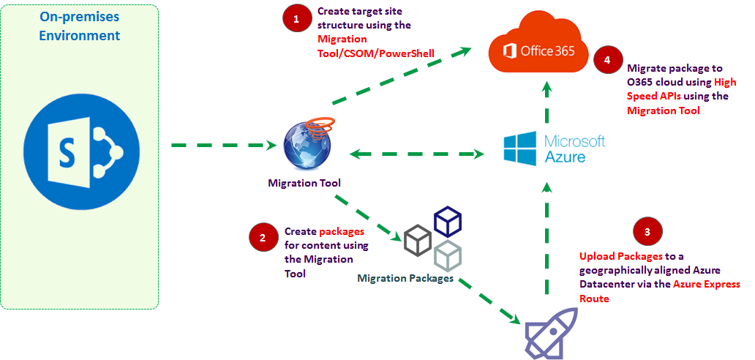

Figure -High Speed Migration with Azure Express Route

## Disk Shipping

The major steps of Disk Shipping include:

**Steps performed at customer end:**

* Site structure on the target environment including Sites/Subsites/Lists/Libraries etc. is created before the actual migration exercise commences
* The content to be migrated is de-constructed into smaller packages and corresponding manifest files (which carry information like content attributes to preserve fidelity of the information) using standard PowerShell scripts.
* An Import Job is created via the Azure Portal for notifying Azure of the Disks being shipped for migration

**Steps performed in partnership with Microsoft:**

* The **packages are exported on disk drives which are then encrypted using BitLocker and physically shipped to the nearest data-center, and mounted on the Azure Blob Storage**.
* A PowerShell based migration Job is created to export the packages over to the O365 SharePoint Online tenant using High Speed APIs.

This option makes for the fastest turnaround on migration requests and should be used when migration volumes are among the highest.

***Recommendation****: Use this option in case the volume of content exceeds 5TB*

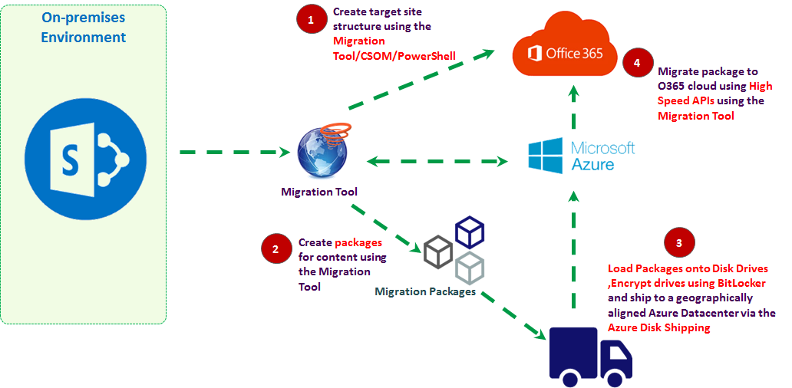

Figure -Figure: High Speed Migration with Disk Shipping

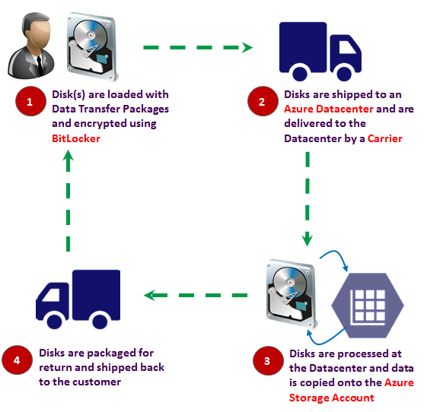

Figure -Typical Life-cycle of Disk(s)

# **The Tool Perspective**

A number of manual command-driven steps of the High Speed Migration process are automated by standard 3rd party tools like Sharegate, AvePoint and Metalogix.

Automation of the following significant activities using a standard tool will save effort and reduce errors:

1. Packaging of content for upload onto Azure Blob Storage
2. Upload of packages to the Azure Blob via the internet – for the express route.
3. Creation of Migration Job for exporting content to the O365 subscription
4. Creation of destination site structure

Tools can be evaluated on a case-to-case basis based on content volume, complexity and timeline / roadmap for individual customers.

# **Observations**

The broad observations w.r.t. use of the High Speed Migration options are as follows:

1. The High Speed Migration options are services offered by Migration for a cost**. Typically, a discussion is required with Microsoft enterprise licensing** team on a case-to-case basis for customer to ascertain the specifics of the cost involved.
2. Typical factors influencing the cost of using the ‘Azure Express Route’ include

* Virtual Machine Type and Uptime
* Data Storage
* Outbound Network Transfers
* Transactional Costs including read/writes to and from containers and Queues

1. Typical factors influencing the cost of using ‘Disk-shipping’ include

* Handling Fee per Disk
* Cost of returning Disk(s) to the customer

1. Only content and associated meta-data can be migrated.
2. Customization would need to be evaluated for re-development, discarding or as inclusion in new OOTB features of O365 making them redundant.
3. The destination site structure/hierarchy needs to be created manually (or using 3rd party tools)
4. **Migration speeds** can reach **10GB/Hr. or higher**
5. Managed-meta data columns cannot be migrated via the High Speed Options
6. Only 3.5 inch SATA II/III internal hard drives are supported for use with the ‘Disk Shipping’ service
7. Each hard drive can have a maximum capacity of 8TB
8. The Azure Blob for content upload needs to have a geographical alignment with the datacenter of the O365 subscription.
9. Supported Shipping locations for the Disk option include:

* East US
* West US
* East US 2
* Central US
* North Central US
* South Central US
* North Europe
* West Europe
* East Asia
* Southeast Asia
* Australia East
* Australia Southeast
* Japan West
* Japan East
* Central India

# **Capabilities**

With the new migration API, there’s a lot build around making migration faster and less painless.

Here are some of the capabilities:

1. Preserves basic metadata

With the new migration API, basic metadata is preserved. Some examples would be date modified, date created, Author etc.

1. Preserves permissions

With the new migration API, all permissions are preserved. This means that when migrating content over, the integrity of the content is not compromised as to who had access to what and the level of permission.

1. File Share Migration

With File Share Migration, all metadata is preserved. Permissions to files which get migrated are also preserved.

1. Speed of Migration

Each package will have two containers:

1. One Azure Blob Container for Content
2. One Azure Blob Container for Manifest

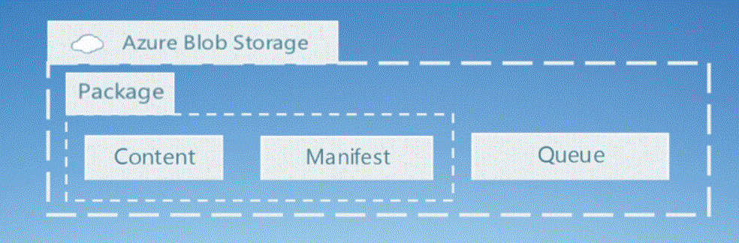

Migration has been tested to be 5x faster than CSOM and negates the throttling scenario generally associated with CSOM and legacy API’s.

1. Real time Updates

Azure Queue will provide real time updates as to what is happening and what files are being ingested.

1. Logging

Post migration, log file(s) will be generated with the complete operation as to what has happened with date time stamp and what has failed.

1. One CSOM call to start the migration

The CSOM call will basically trigger the whole migration process. This is a simple call. Please see below:

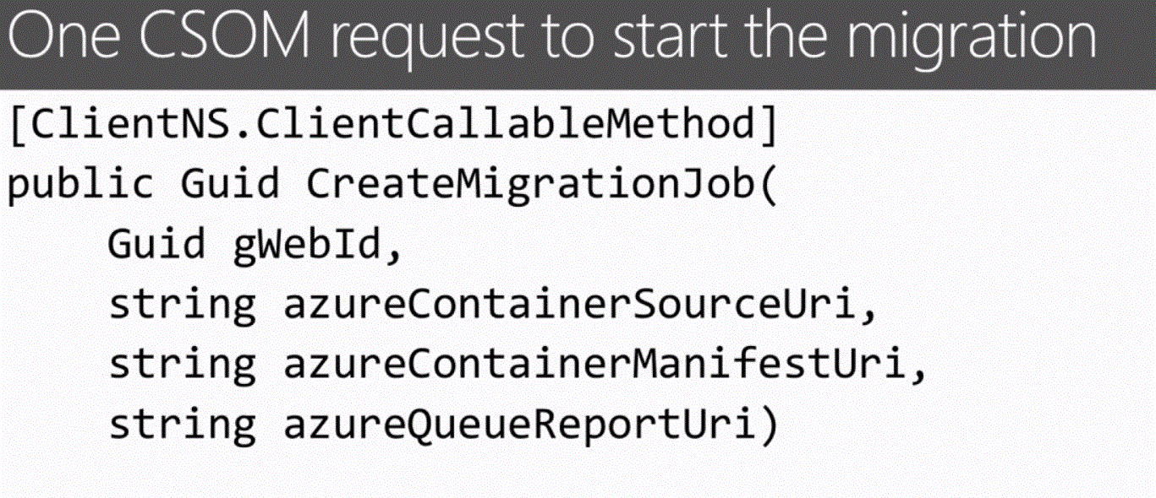

1. No Legacy API’s and CSOM calls

With the new approach, there would be no legacy API calls and very limited CSOM call (please refer point 7). This negates the risk of, if being implemented improperly, it runs the risk of overwhelming SharePoint servers, making them unresponsive to standard users.

1. Scalable Azure resources

Thanks to leveraging the [scalability](http://azure.microsoft.com/en-us/documentation/articles/storage-scalability-targets/) and power of Microsoft Azure, the infrastructure supporting the migration pipeline is better equipped to cope with demand (storage for uploading content can support large scale multi-TB migrations) to maintain migration performance. Azure has been designed to deliver a greater throughput than SharePoint Online and the pipeline will utilize the backend internal Microsoft network to help achieve this.

1. Transparent to other Multi-tenant users

As the majority of “heavy lifting” and processing occurs on the back-end of the cloud infrastructure a typical user of SharePoint Online will see no impact from a migration taking place on the shared infrastructure.

1. No throttling

Throttling for CSOM based migrations was introduced by Microsoft to ensure that the experience for their SPO users was not adversely impacted by excessive CSOM actions and calls.

# **Limitations**

Let us look at some of the limitation which High Speed Migration using new migration API can have:

1. *Size and quantity of files being migrated*

Migrating many smaller files takes longer than fewer larger files. Part of this is due to the duration of building packages with many smaller files.

1. *Capacity and latency of Internet connection*

Slower internet connection will slow down the overall migration process. AS an alternative, Microsoft offers saving all packages to a hard drive and shipping it.

1. *Location of Azure Storage*

The location of Azure storage is also a considerable factor in the amount taken to migrate. Choosing one which is at the same location, saves considerable time. For the list of available data centers, please refer to point 12 under Observations section.

1. *Concurrent migrations into a single content database*

Currently the API is limited to processing a single package into any one content database at a time. In SharePoint Online and OneDrive for Business, content databases are auto-assigned for each site collection and OneDrive. This also means that if your content is spread across multiple content databases, you will need separate packages for each of them.

1. *Incremental or Delta Migration*

This is also a basic feature of professional third-party migration tools, which allows users to continue using their on-premises environments until the end of the migration. An incremental migration then picks up the changes and reproduces them in the target. This functionality is also not part of the current API.

# **Supported and Unsupported features of HSM**

Following are some of the supported and unsupported features with the new API:

Supported:

* Authorship
* Permissions, users and groups
* Multiple file versions
* Manifests can have references to multiple versions of a file, major and minor up to the limits imposed within SPO.
* Preserves identifiers (item Ids)
* Document Libraries
* Custom Lists with and without attachments
* Item metadata

Unsupported:

* + .aspx files (no support for web parts and such)
  + Workflows
  + Events
  + Cases such as Document sets, InfoPath need testing – they may be supported as is (however xsn templates would require publishing in advance for a document library/list)

# **References**

Please refer to the following URLs for further information on Disk Shipping and Azure Express Route options.

<https://azure.microsoft.com/en-in/documentation/articles/storage-import-export-service/>

<https://azure.microsoft.com/en-us/services/expressroute/>

<https://azure.microsoft.com/en-us/documentation/articles/expressroute-introduction/>